Appendix J-5

Thesis/Project 2 Meeting Record Assessment Rubric

|  |  |  |  |
| --- | --- | --- | --- |
| **Project/Thesis 2 Logbook Rubric** | | | |
| **Group No.:** |  | | |
| **Project:** | **Enhancing File Sharing and Data Management Capabilities at Batangas State University Alangilan Faculty Through a Distributed File System** | | |
| **Adviser:** | Mark Rondol P. Abdon | | |
| **Logbook Assessment (10%)** | | | |
| 1. Number of Meetings with Supervisor – these are weekly meetings which took  place between the student and the supervisor and the relevant meeting record sheet was documented. | | | |
| **Area 1** | | **Number of Meetings** | **Total score** |
| Number of meetings held during the 18 weeks semester period | | None | 0 |
| Less than 5 | 10 |
| 5 to 6 | 15 |
| 7 to 8 | 25 |
| 9 to 10 | 35 |
| More than 10 | 40 |
| **Area 1 score** | | |  |
| 2. Progress Report – Execute and lead research project planning, budget, direct and control tasks, resources effectively (which has been indicated in the meeting record). | | | |
| **Area 2 score ( 1 to 5)** | | **Progress Report** | **Total score** |
| Average completion of agreed tasks during the semester | | Completed none | 0 |
| Completed at least 25% | 20 |
| Completed at least 50% | 30 |
| Completed at leaset 75% | 40 |
| Completed at least 85% | 50 |
| Completed 100% | 60 |
| **Area 2 score** | | |  |

**Total score out of 100 (Area 1 + Area 2)**

**Other comments**

***\*Please key into white coloured cells only***

**SUMMARY OF LO SCORES %**

|  |  |  |
| --- | --- | --- |
| **LO7** |  |  |
|  |  |  |

**CONVERTED MARKS (%)**

|  |  |
| --- | --- |
| Objectives | Percentage |
| To develop a website that has the following capabilities:  1.1 Upload **40%**  1.2 Download **80%**  1.3 Share **0%**  1.4 Search; and **0%**  1.5 Encryption of files **0%** | **20%** |
| 1. To incorporate web application and Distributed File System with the campus network's existing infrastructure for enhanced file management and access capabilities. **0%** | **0%** |
| 1. To create a DFS replication group to automatically synchronize and replicate data between designated servers for redundancy and data recovery. **0%** | **0%** |
| 4. To map the virtual DFS path to the actual physical location of the files in the server using Django Framework. **0%** | **0%** |

**Engr. Mark Rondol P. Andon**

Adviser

|  |  |  |  |  |
| --- | --- | --- | --- | --- |
| **Dr. Jeffrey S. Sarmiento** |  | **Dr. Jen Aldwayne Delmo** |  | **Engr. Mark John Fel Rayos** |
| **Panel Chairman** |  | **Panel Member** |  | **Panel Member** |

This is the current sign-up page of the web application

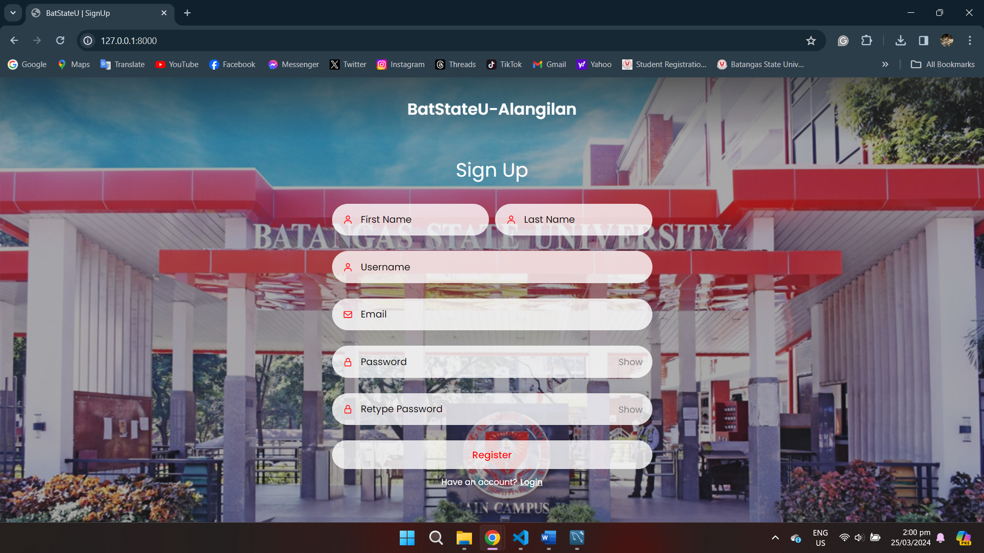

This is the current Login Page of the web application

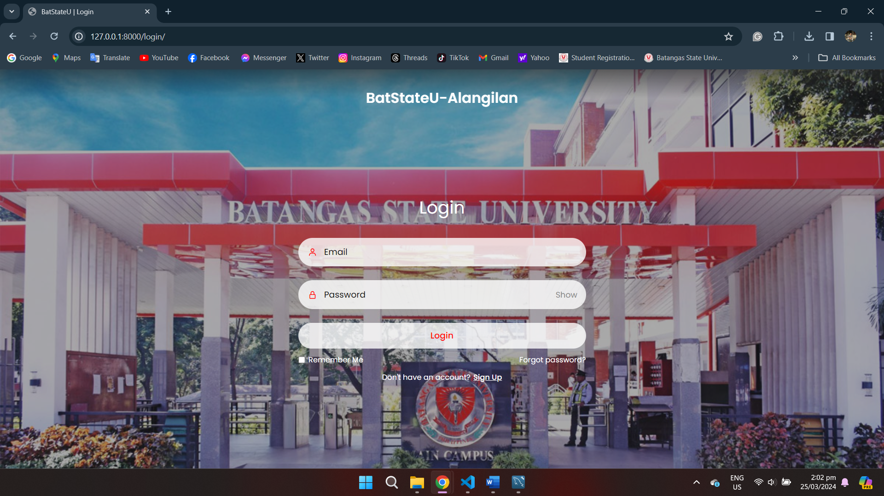

The upload button and download function is now available, yet uploading folder is still in progress. Also, the design of the dashboard is not yet develop into code.

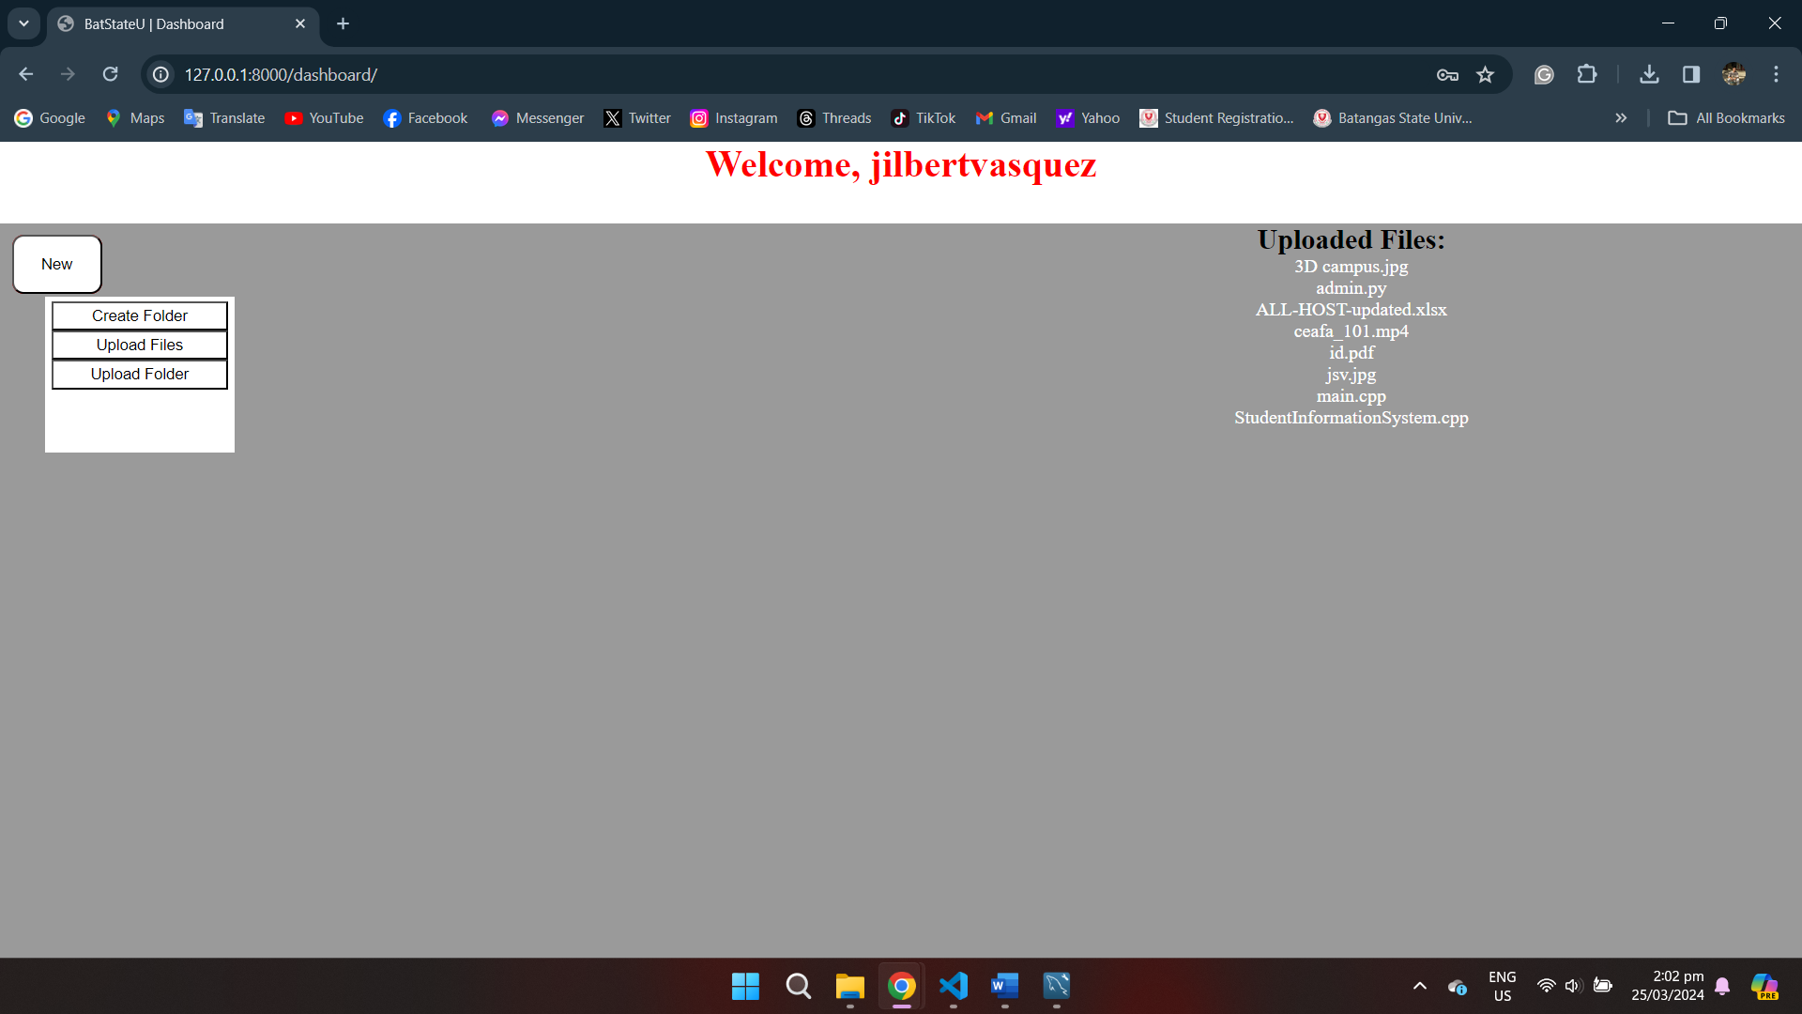

This is the current design of the dashboard of web application, but not yet develop. It may still change depends while working and developing the web application but the main functions will still remain in the application.

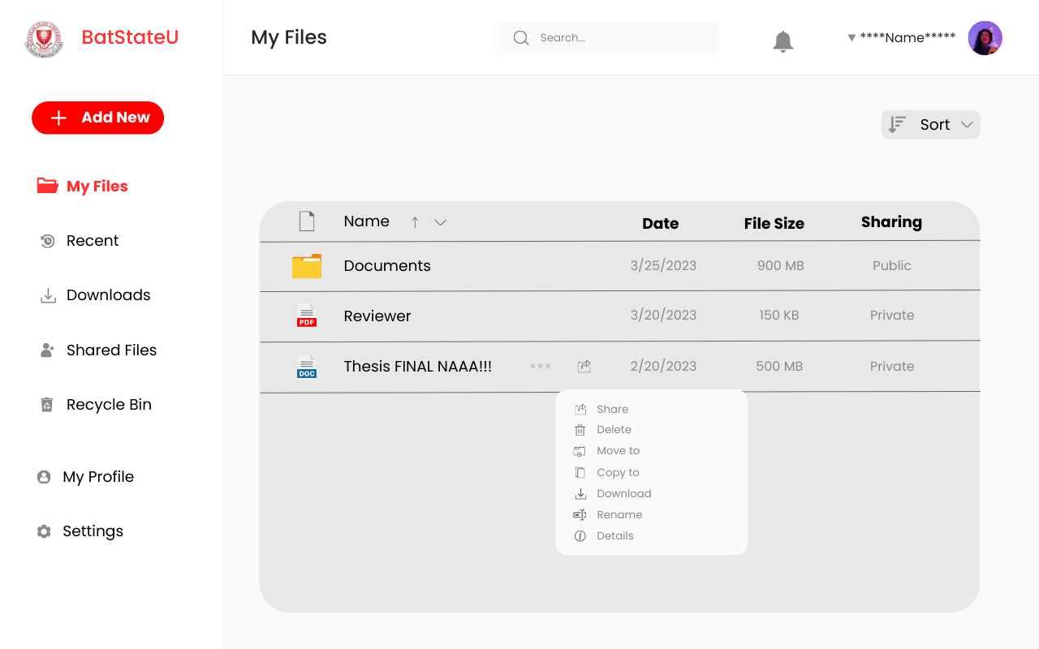

Current Login Code

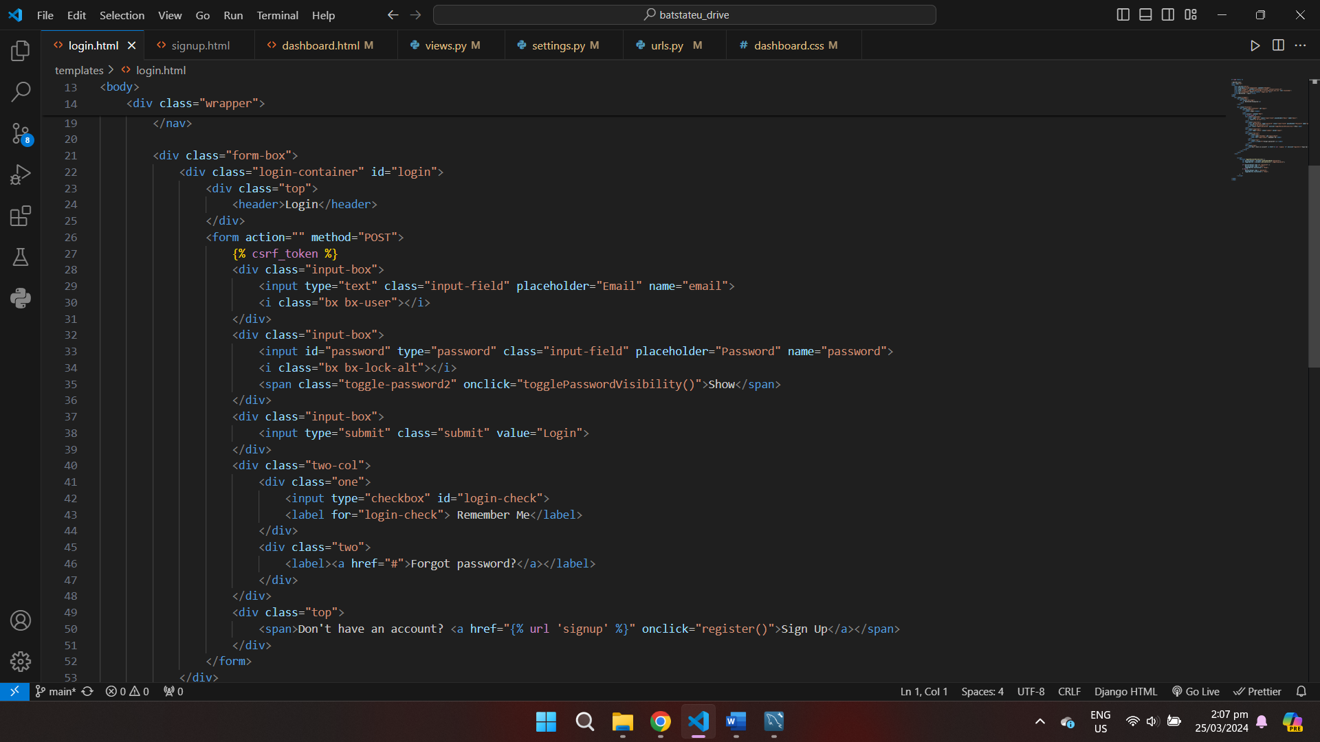

Current Sign-Up Code

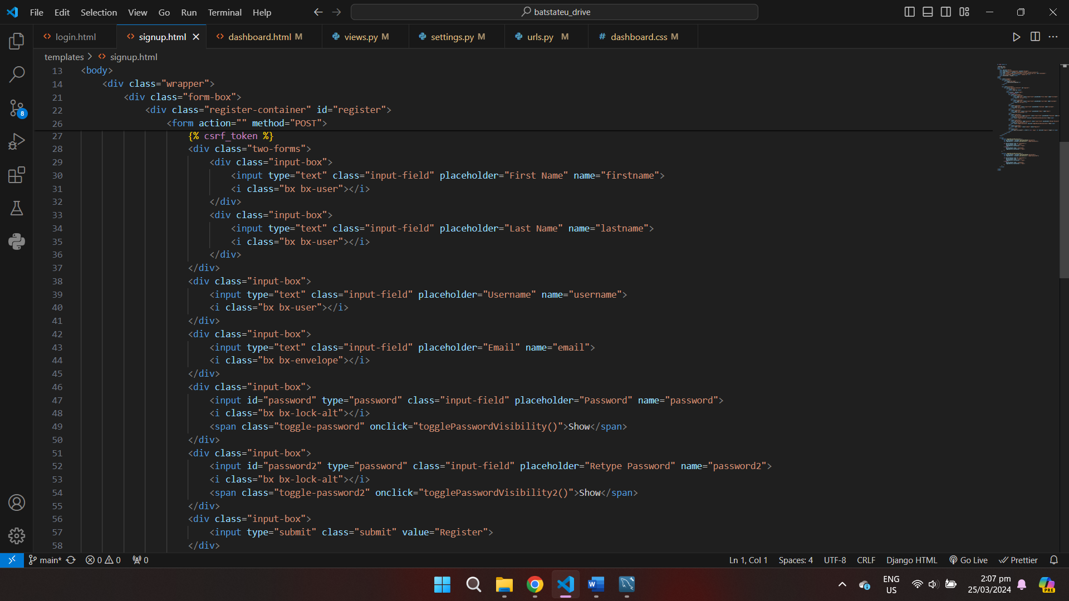

Current Dashboard Code

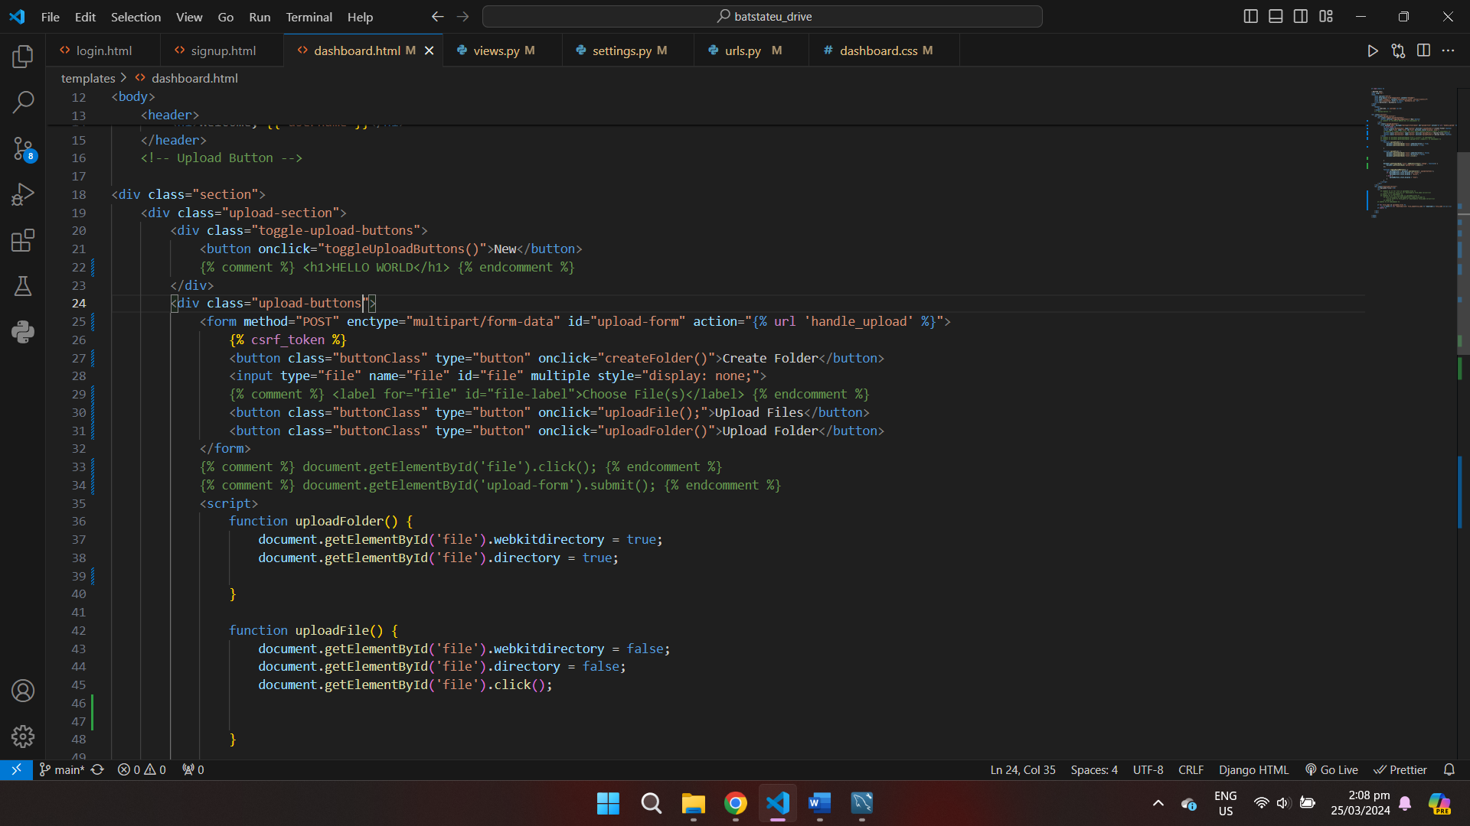

Views files where specific functions is performed (request method, login and interaction to database)

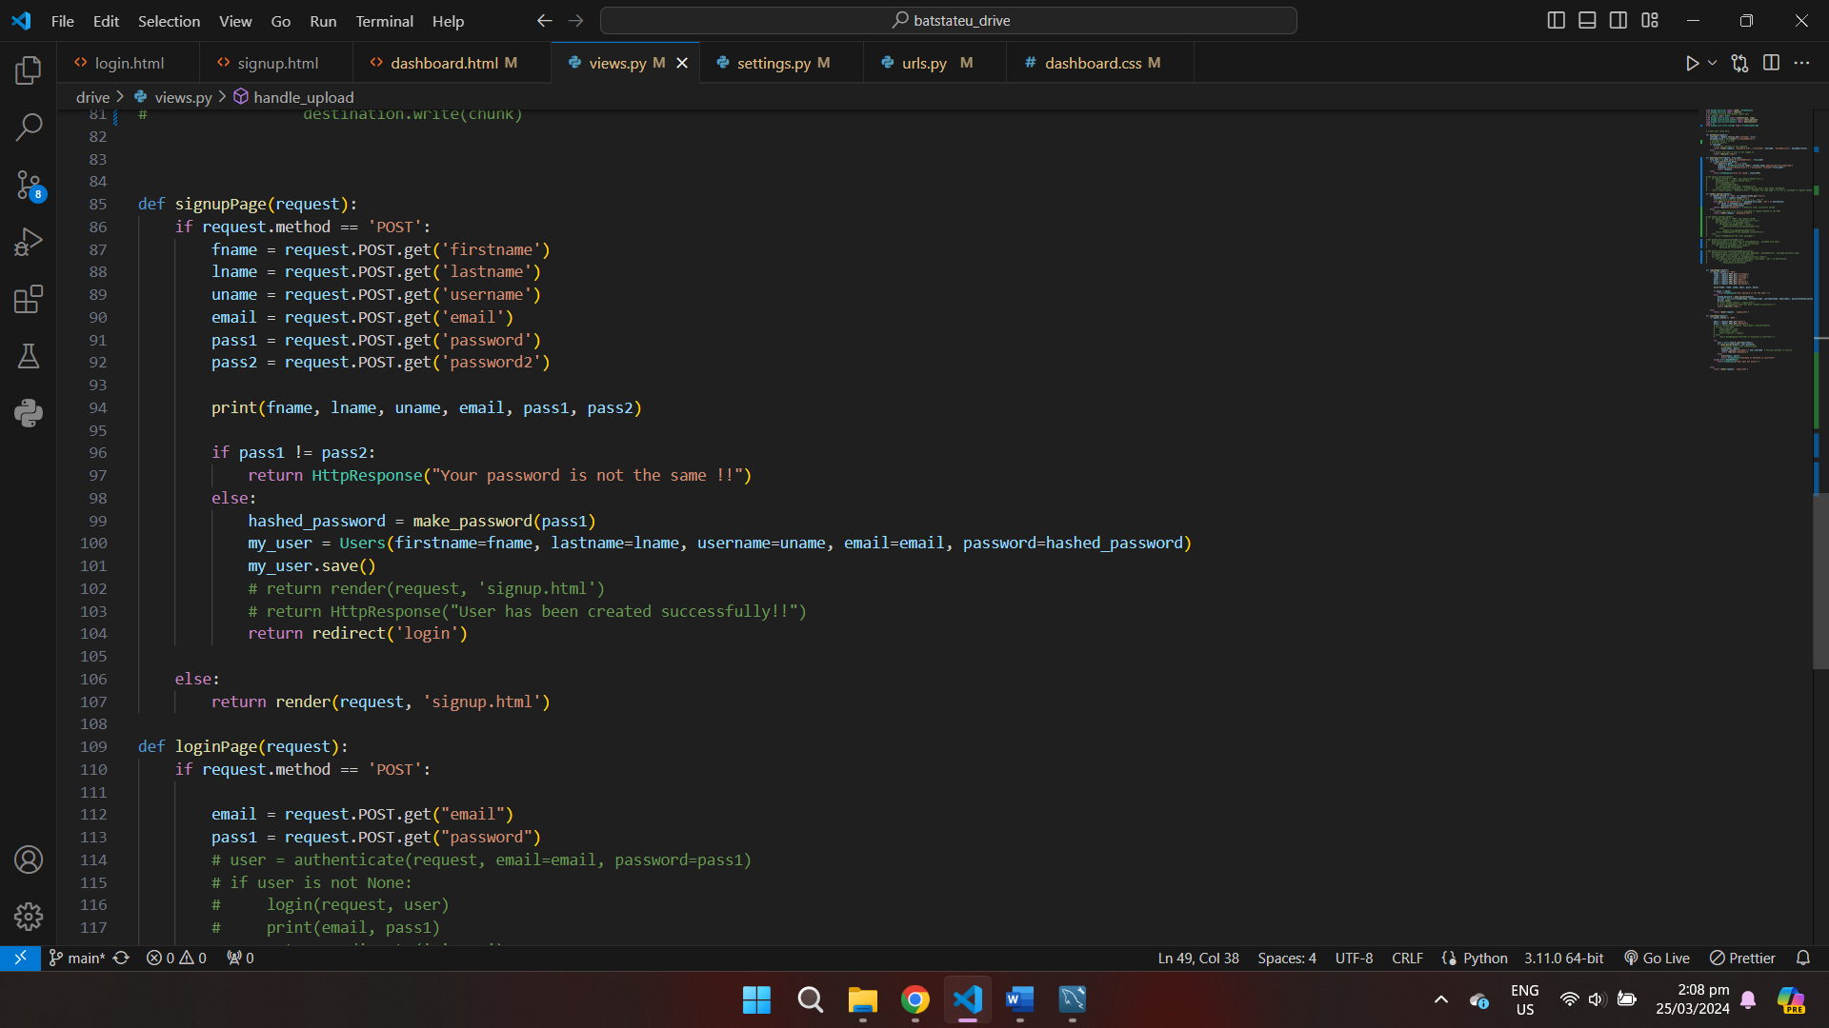

Urls file where you need to specify the paths and the functions inside views files

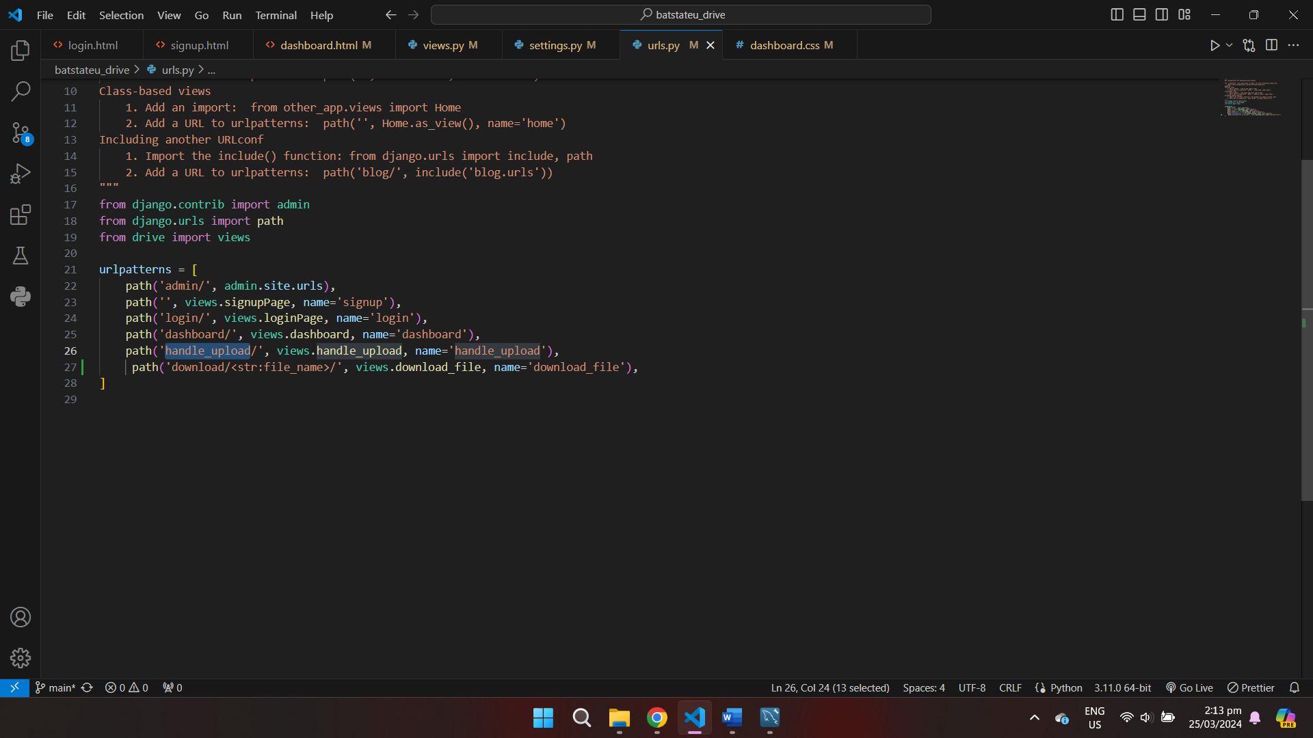

Changing default database in Django framework, from sqlite to mysql database

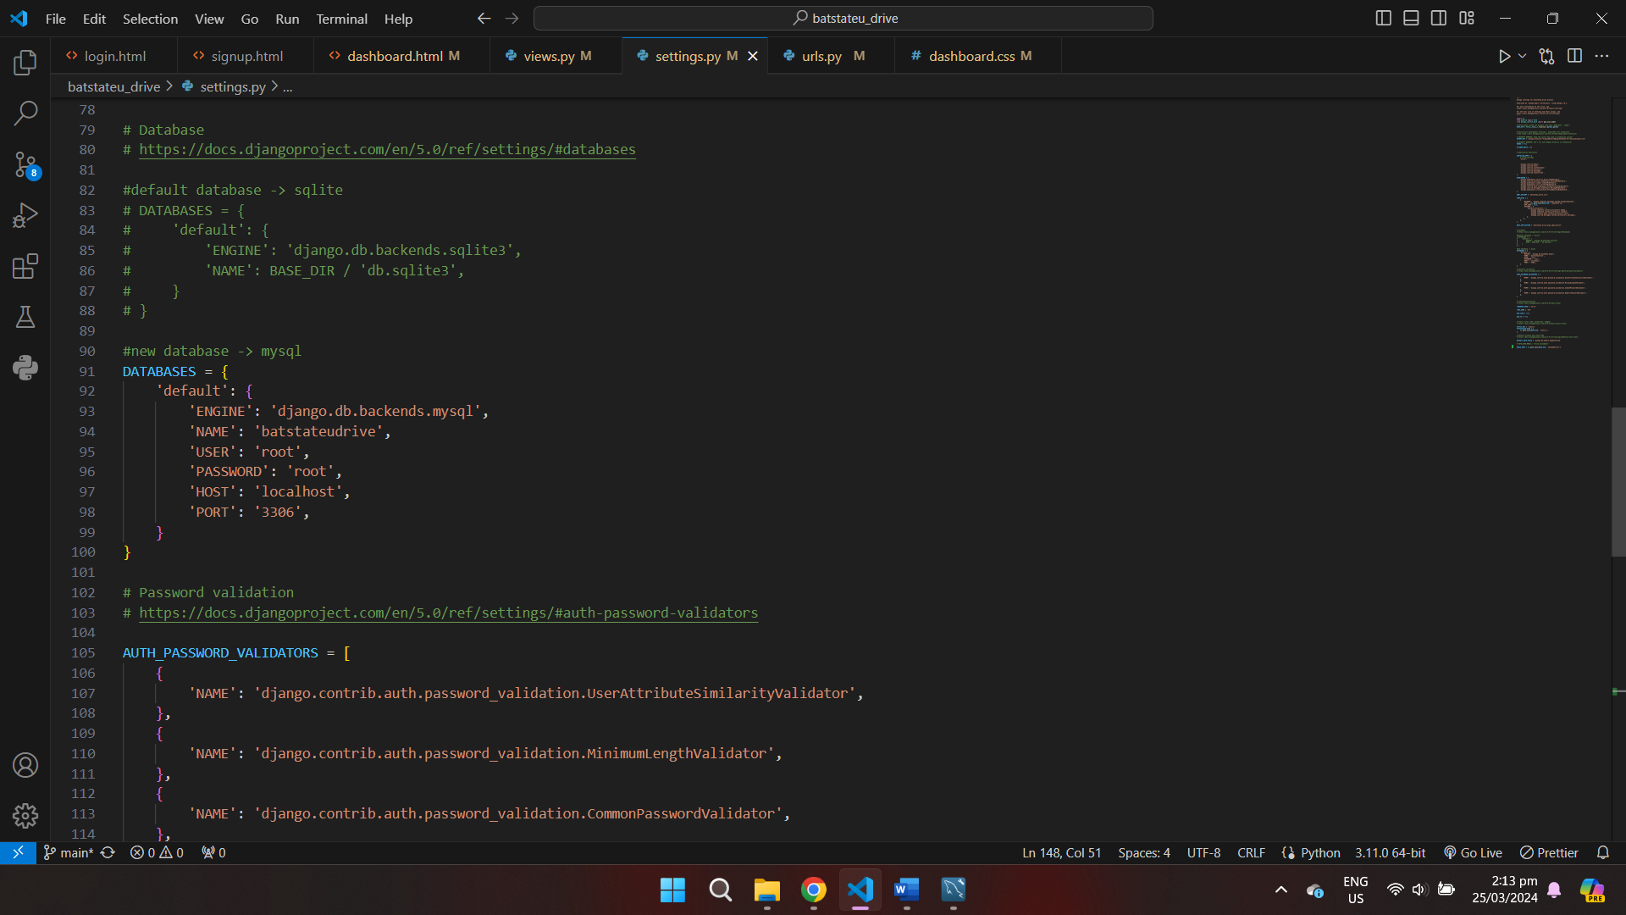

Importing the model that we created in workbench to Django Framework

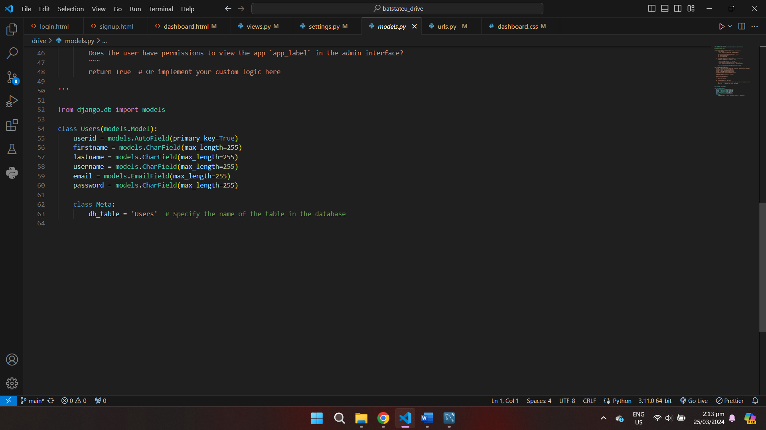

Initial model created at mysql workbench

